Laplace Land

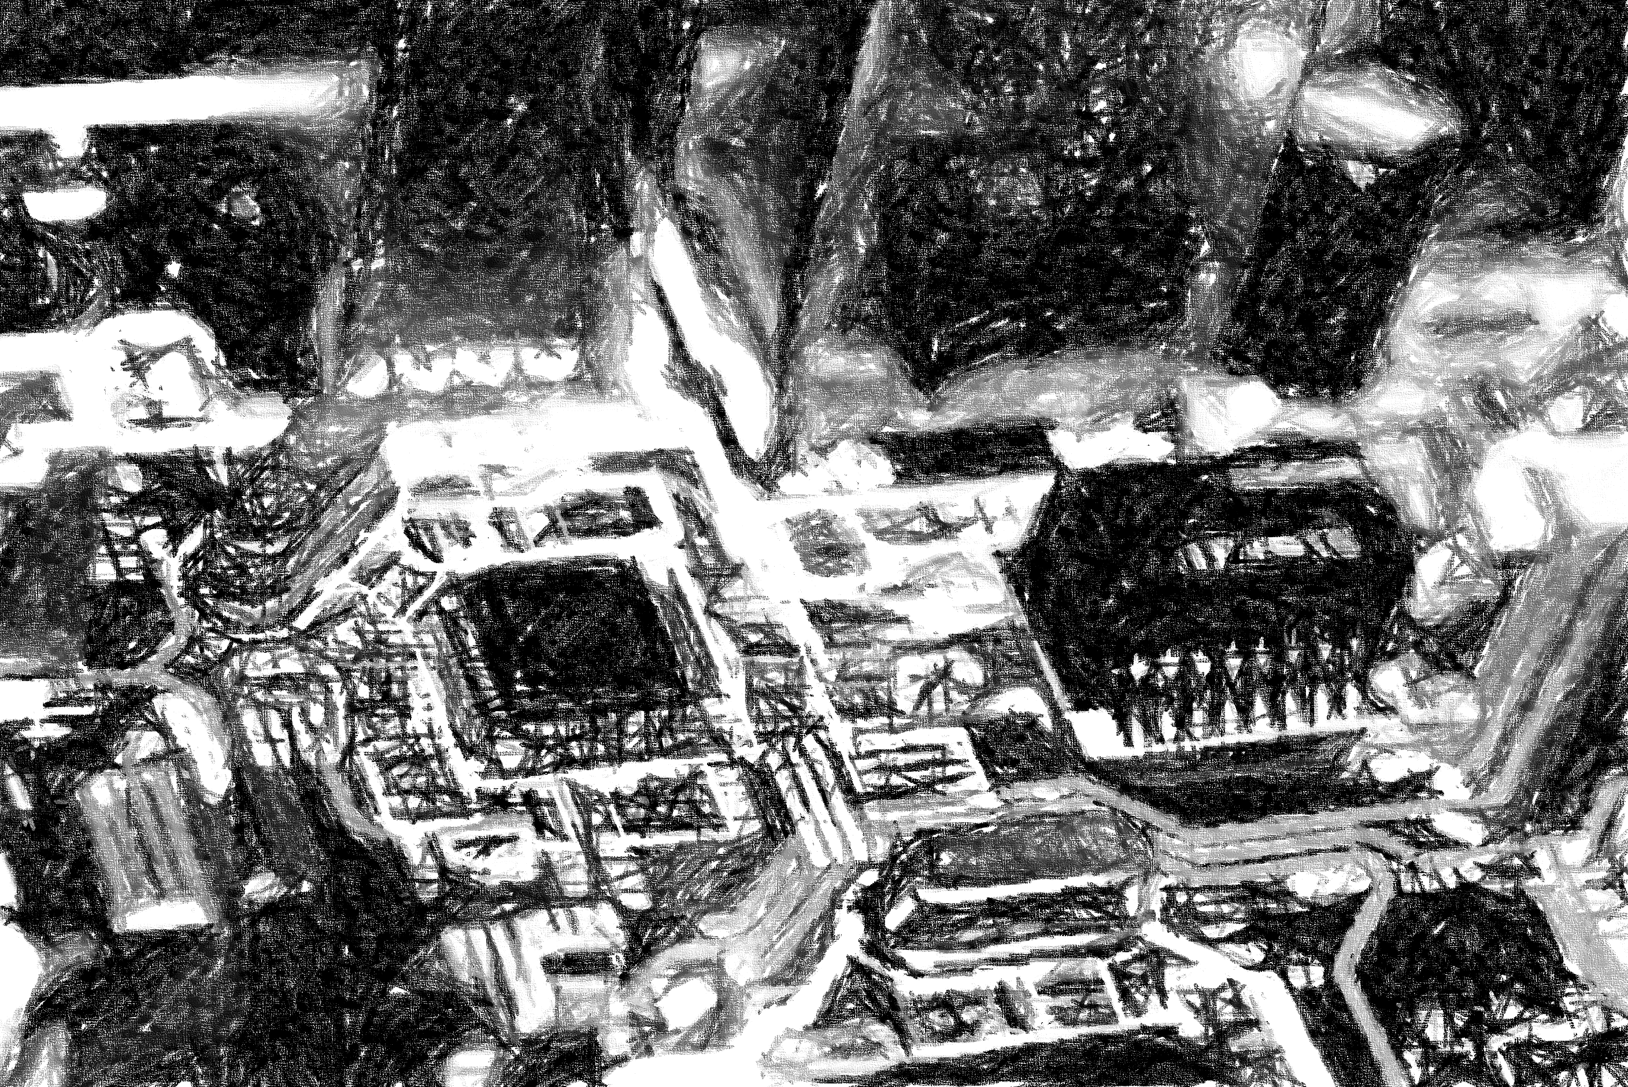****

Abstract:

This lab identifies the processes taken to extrapolate information from a circuit analytically, by the use of Spice, and the use of MATLAB. Throughout the course of this lab it was thought that hand calculations were long and tedious and this had confirmed it so. MATLAB and Spice are a far more widely used and accurate means of extrapolating a solution from a complex system such as the one used in this lab.

David Houston  
EE 225  
Dr. Bruce Barnes

“Tricky business, Laplace is”

# Introduction

This material for this lab was:

* MATLAB
* LT SPICE

The circuit below was analyzed both mathematically and synthetically using the provided resources.

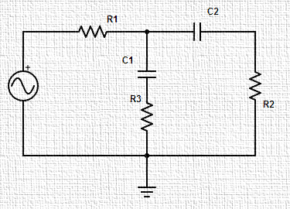

# Hypothesis

To test the analysis of the circuit, hand calculations were made to determine the temporal response of the system. Below is our characteristic equation of the system:

If the system is analyzed with zero initial conditions, then it can be said that it has the transfer function:

From here it was determined through a prolific amount of algebra and Laplace identities that the temporal output response (including initial conditions) of the system modeled the following equation:

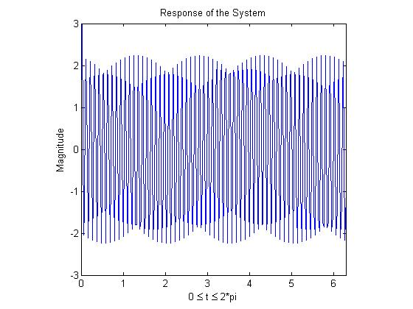

See Appendix B for mathematical explanation

# Procedure

After analyzing the output function of the hand calculations, it was then concluded that a secondary and tertiary test should be taken in order to determine the validity of the statement. The following mathematical formula indicates the output as perceived by MATLAB:

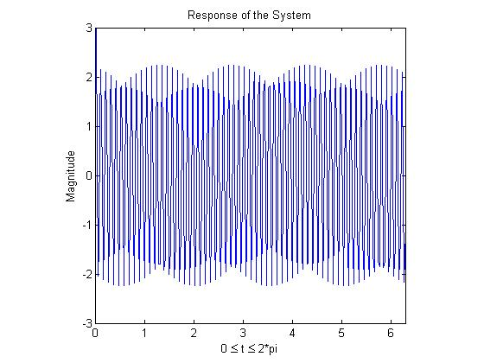

See Appendix A for MATLAB code

The two solutions produced by MATLAB are almost identical to the hand calculated values, excusing errors from Tailor Series approximations. This indicates that not only is MATLAB as worthy tool of use, but that it is necessary to save both time and money when in cooperating it into our circuit analysis.

The same operation was performed on LT Spice; however, an output looking not like the rest was observed below:

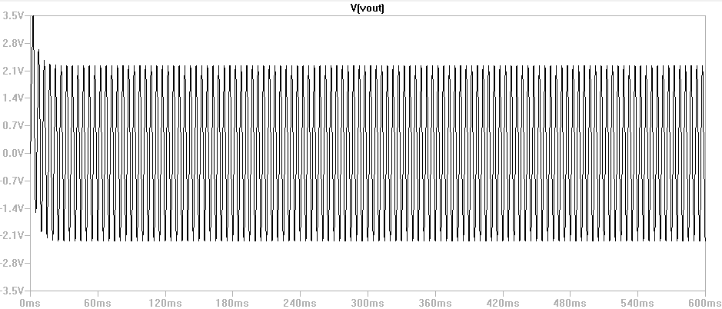

The reason for a much more balanced wave equation is because LT Spice makes hundreds of thousands of calculations to determine the wave shape in accordance with the circuit. However, MATLAB nor the average human being, takes these small operators into consideration and therefore, as a result, a somewhat distorted wave is produced.

# Conclusion

During the scope of this lab it has been noted that while MATLAB and our impressive human brains are fully able to synthetically calculate the response of a system, it is still not quite as accurate as generating it with a tool specifically made top produce. MATLAB, while it produced the correct equation, failed in the plotting process. Had a more powerful machine been accessible, with the ability to calculate thousands of data points per cycle of the wave, a much smoother and more accurate shape would have been produced. I would highly advise the use of MATLAB over LT Spice when trying to calculate an exact wave function. However, I would lean more towards LT Spice if trying to export the wave’s shape in temporal space.

# Appendix A

**Code:**

%% Circuits III Lab 2

clc

clear

format SHORT

syms t s

R1 = 4000;

R2 = 10000;

R3 = 5000;

C1 = 0.2*10^-6;

C2 = 0.4*10^-6;

Vc1 = 5;

Vc2 = 5;

vint = (20 + 5*cos(2*pi*200*t))*heaviside(t);

Vins = laplace(vint,t,s);

pretty(Vins)

A = [(R1+1/(s*C2)+R3) -(1/(s*C2)+R3); -(1/(s*C2)+R3) (R3+1/(s*C2)+1/(s*C1)+R2)];

B = [Vins-(Vc2/s);0];

Soln = inv(A)*B;

Vos = R2*Soln(2);

pretty(simplify(Vos));

vot = ilaplace(Vos,s,t)

ezplot(t,vot)

**Output:**

5 s 20

--------------- + --

2 2 s

160000 pi + s

/ 5 s 15 \

590295810358705625 s | --------------- + -- |

| 2 2 s |

\ 160000 pi + s /

---------------------------------------------

1298650782789152375 s + 295147905179352825856

vot =

(exp(-(295147905179352825856*t)/1298650782789152375)*(9333096161056214253327044437219178493322406137298583984375*pi^2 + 4017345110647475507062453527010741785632257210109132800000))/(1298650782789152375*(1054058659774298889027859981855087890625*pi^2 + 340282366920938463463374607431768211456)) - (1361129467683753792259819967610880000000*pi*sin(400*pi*t) - 2395587863123406565972409049670654296875*pi^2*cos(400*pi*t))/(1054058659774298889027859981855087890625*pi^2 + 340282366920938463463374607431768211456)

# Appendix B

**Analyzed without any initial conditions:**

­

**Analyzed only with initial conditions:**

**Solve for the temporal response with the equations:**